Day/ Date Place Itinerary
Jan 01/ Tue JFK Depart at … hrs by flight #....

Day 01 Mumbai Arrive at … hrs by flight #....
Jan 02 Meeting/ assistance and transfer to the hotel
Wed (accommodation is protected for immediate occupancy)
Overnight: Taj Mahal (Tower Wing/ Sea view rooms)

Day 02 Mumbai Breakfast at the hotel
Jan 03 Morning: At leisure
Thu Afternoon: City Tour: Mumbai
Visit the Gateway of India, Mumbai’s principal landmark. This arch of yellow basalt 0was erected on the waterfront in 1924 to commemorate King George V’s visit to this colony in 1911. Drive past the Bombay High Court built in Gothic style and the Old secretariat. The ornamental university building with its 280 ft. high Rajabhai Clock Tower, the ornate Victoria Terminus, the colorful Crawford Market, the Flora Fountain in the large bustling square at the heart of the city, the Prince of Wales Museum which houses a varied collection of China-ware, miniature paintings and sculpture, Afghan Church built in memory of those who fell in the First Afghan War. Drive along the Marine Drive which is known as the Queen’s Necklace. View the memorial to Haji Ali, a Muslim Saint. This unusual shrine stands on an island 500m out at sea and is linked by a causeway to the mainland. Malabar Hill with the Kamla Nehru Park Visit the Hanging Gardens which offer a splendid view of the city, and drive past the Malaxmi Temple, the Jain Temple and visit Mani Bhavan where Mahatma Gandhi stayed during his visits to Bombay.
Dinner at the hotel
Overnight: Taj Mahal (Tower Wing/ Sea view rooms) (B/D)

Day 03 Mumbai Breakfast at the hotel
Jan 04 Morning: Excursion to Elephanta Caves
Fri The island of Elephanta is just an hour away from Bombay by motor launch. The cave temples here, excavated between the 5th and 8th centuries AD, are famous for their magnificently sculpted panels. The best known is one that depicts the Maheshmurti - a three-headed image of Lord Shiva. This island was so named by the Portuguese after the large stone elephant near the landing place and which now stands at the Victoria and Albert Museum in the mainland. The caves are reached by a stairway up the hillside from the ferry landing.
Afternoon: At leisure
Dinner at the hotel
Overnight: Taj Mahal (Tower Wing/ Sea view rooms) (B/D)

Day 04 Mumbai Breakfast at the hotel
Jan 05 Transfer to the airport
Sat Mumbai Depart at 1240 hrs by flight # IC 865
Goa Arrive at 1355 hrs
Meeting/ assistance and transfer to the hotel
Afternoon: At leisure on the beach
Dinner at the hotel
Overnight: Taj Holiday Village (B/D)

Day 05 Goa Breakfast at the hotel
Jan 06 Morning: Old Goa and Panjim City Tour
Sun Visit Panjim Goa’s capital, a small town endowed with the quaint charm which characterises Goa. Old villas, a profusion of squares, wide treelined avenues, and narrow cobbled alleys weaving through the older parts of the town with their tiled roofs and balconies reminiscent of the Iberian settlers who built them. A winding road climbs the long wooded ridge of Altinho where stand the ancestral houses of some of the wealthy Goan families.
Dona Paula, a landmark and picnic spot from where one can have a wonderful view of Marmagoa Harbour, pass by Gaspar Dias Beach and proceed to Old Goa to visit the Basilica of Bom Jesus which houses the mortal remains of St. Francis Xavier kept in a rich casket, and the Se Cathedral, (1510) a towering white structure with a grand baroque interior, 14 gold embossed altars and Doric arches which create an atmosphere of great dignity and splendour.

Afternoon: At leisure on the beach/ no transport included
Dinner at the hotel
Overnight: Taj Holiday Village (B/D)

Day 06 Goa Breakfast at the hotel
Jan 07 Day at leisure on beach/ no transport included
Mon Dinner at the hotel
Overnight: Taj Holiday Village (B/D)

Day 07 Goa Breakfast at the hotel
Jan 08 Morning: at leisure on beach/ no transport included
Tue Check at the hotel
Transfer to the airport
Goa Depart at 1500 by S2 118
Delhi Arrive at 1725 hrs
Meeting/ assistance and transfer to the hotel
Dinner at the hotel
Overnight: Claridges hotel (Deluxe rooms) (B/D)

Day 08 Delhi Breakfast at the hotel
Jan 09 Morning: City Tour: OLD DEHI
Wed OLD DELHI- the 300-year-old walled city built by Emperor Shah Jehan in 1648 as his capital and named after him. The magnificent Red Fort built of red sandstone. Within its walls are marble palaces and a grand audience chamber, the Diwan-i-Khas, where Moghul emperors held court and the Peacock Throne once stood. Opposite the fort are the black and white onion dome and minarets of the Jama Masjid, the most elegant mosque in India. Drive past Kotla Firoze Shah, ruins of an old fort of the 14th Century, see the Ashokan Pillar of 3rd BC. Then visit Raj Ghat, where Mahatma Gandhi was cremated in 1948.
Drive through the old city subject to traffic restrictions.

Check-out at the hotel at 1200 hrs
Lunch on own at a local restaurant
Approx. at 1500 hrs: Transfer to Safdarjung Rail station
Report to the Palace on Wheels desk at 1600 hrs

POW departs Delhi at 1800 hrs
The journey of a lifetime begins at the Delhi Cantonment station where the guests are accorded a warm, traditional welcome before the Palace- on-Wheels pulls out into the night… for a week-long luxury cruise through fascinating Rajasthan

Day 09 Jaipur Arrive at 02.00 hrs.
Jan 10 The first stop of the Palace-on-Wheels is Jaipur, one of the most well
Thu planned cities of the world of its time. This capital city of Rajasthan, popularly known as the Pink City,was founded by Maharaja Sawai Jai Singh II, in 1727 A.D.
To explore the city, an air-conditioned coach takes you to Hawa Mahal or the Palace of Winds, which is a remarkable five storeyed building a ong the main street of the old city in pink splendour with semi-octagonal and delicate honey combed sandstone windows. This is followed by a visit
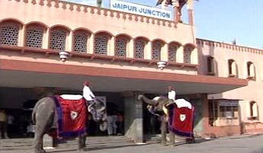

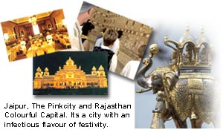
Amber Fort, eight km away from City, where rides on caparisoned elephants add to the ambience. Shop for Jaipur's famous jewellery, handicrafts, carpets, blue pottery and textiles. Near Ajmeri Gate is located Rajasthali- the only Rajasthan Govt. Emporium selling genuine handicrafts at fixed prices. After lunch at a Palace Hotel, you are off to the City Palace, home of the erstwhile royal family. Right across the road from the City Pa ace is the Jantar Mantar, the largest observatory built by Sawai Jai Singh II.
The Luxury coaches will take you back to Palace-on-Wheels around 6.30 pm.
Dinner on Board
Depart for Jaisalmer at 19.30 hrs

Day 10 Jaisalmer Arrive at 08.1 5 hrs
Jan 11 In the heart of the Thar desert lies Jaisalmer, founded by Rawal
Fri Jaisal,in 1 1 56 A.D. Here the yellow sandstone fort is an imposing sight,towering magnificently over the city. Discover the painstakingly latticed havelis or mansions with their grand facades.

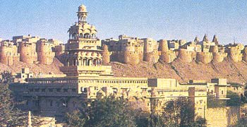

The Nathmalji-ki-haveli, Patwon-ki-haveli and Salim Singh-ki-haveli are fine examples of the stone carver's skill.
Shop at Rajasthali-the only Rajasthan Govt. emporium, for fine pattu shawls, mirror work & embroidered articles, wooden boxes, trinkets, silver Jewellery and curios
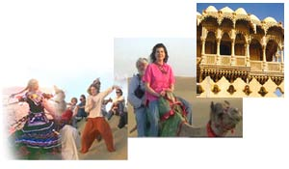
After lunch on board, go for an exciting came ride on the sand dunes of Sam, before sipping a refreshing cup of tea. Enjoy the dinner and the cultural programmes at a hotel in Jaisalmer
The train leaves for Jodhpur at night at 23.00 hrs

Day 11 Johpur Arrive at 07.00 hrs
Jan 12 on this day morning the Palace-on-Wheels is in Jodhpur, a city ringed
Sat by a high stone wall with seven gates and several bastions
This is the second largest city of Rajasthan; founded by Rao Jodha in 1459 A.D. is known for its rock-solid Mehrangarh Fort.
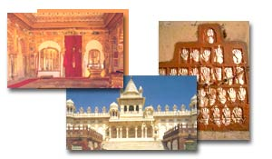

The grand palaces within -Moti Mahal, Sheesh Mahal, Phool Mahal, Sileh Khana and Daulat Khana are impressive examples of architectural excellence. Near the fort complex lies Jaswant Thada, and a group of royal cenotaphs made of white marble.
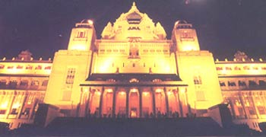
After lunch at a Palace hotel, return to the Palace-on-Wheels.

While in Jodhpur shop for exquisite handcrafted articles including the famous breeches, embroidered shoes, metal curios, silverware, paintings and tie and dye fabrics.
Departure 15.30 hrs

Day 12 Sawaimadhopur Arrive at 04.00 hrs
Jan 13/ Sun
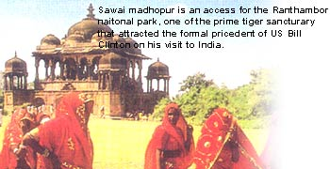
One can almost sense a life of the wilderness, as the Palace-on-Wheels arrives in Sawai Madhopur, a city named after its founder Maharaja Sawai Madho Singh I.
After breakfast a visit is arranged to the Ranthambhor National Park, wherein are located the ruins of a 10th century fort. This wildlife sanctuary is considered to be the country's best for observing andphotographing the activities of the tiger.

The park, covering an area of 392 sq. km is home to more than 300 species of birds. The tiger, hyena, rate, jackal and fox are among those constituting the carnivorous population here. Sawai Madhopur is known for its excusive toys, ethnic ornaments and costumes. Upon return to the Palace-on-Wheels, you leave for Chittaurgarh, when one gets an opportunity to watch the colourful countryside passing by in the daylight

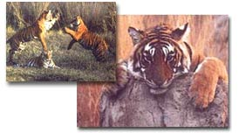
Depart at 10.30 hrs.
CHITTAURGARH Arrive at 16.00 hrs.
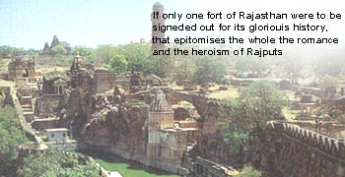

After lunch on board you are in Chittaurgarh. Images of love and valour; scars of battles lost and won...thrice-beseiged, Chittaurgarh Fort is all this and more. Moving legends of honour and pride will echo in your mind as you proceed to Udaipur.
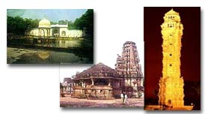

Day 13 Udaipur The Luxury Coach will take you to Udaipur, the Lake City
Jan 14 It was founded by Maharana Udai Singh of Mewar, after the
Mon Sisodia dynasty was driven away by the Mughals, in 1559A.D.
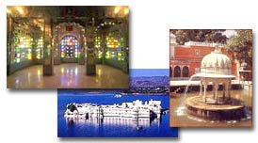
Perhaps the two most beautiful sites of Udaipur are the dream-like marble palaces- the Jag Niwas (Lake Palace) and the Jag Mandir, which appear to rise from the blue waters of Lake Pichhola.
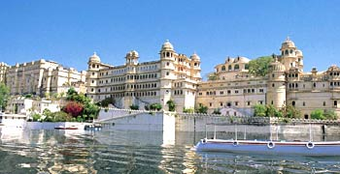
After lunch at Lake Palace Hotel, a visit to the City Palace is exhilarating.
The luxury coach then takes you back to the Palace-on-Wheels at Chittaurgarh, thus winding up a day full of delights.

Day 14 Bharatpur Arrive at 06.30 hrs
Jan 15 Early next morning, the Palace arrives in Bharatpur, the capital of
Tue Maharaja Suraj Mal . After breakfast pay a visit to the world famous bird sanctuary, Keoladeo Ghana National Park, the nesting place for thousands of Egrets, Siberian Cranes, migratory Water Fowl and other species of birds.
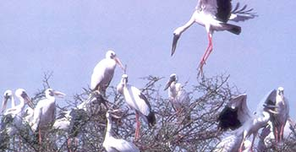

Bharatpur Depart at 9.00 hrs
Arrive at Fatehpur Sikri-the red sandstone Mughal palatial complex. Within the encosure is a mosque built by the Mughal Emperor Akbar and dedicated to Sheikh Salim Chishti, a muslim Sufi saint who blessed him with a son.
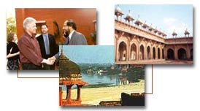
Agra Arrive at 1430 hrs
After lunch move on from the Red Fort and arrive at the Taj Mahal, one of the seven wonders of the world. A pristine monument of undying love. It was built by Emperor Shah Jahan in memory of his beloved queen Mumtaz Mahal. Agra is known for its splendid marble inlay work like the Pietra Dura work on the Taj, leather goods and jewellery.
After dinner on board and a good night's sleep
POW departs Agra at 2100 hrs.

Day 15 Delhi Arrive at 0600 hrs at Safdarjung Rail Station
Jan 16 Breakfast on board (POW)
Wed Approx. at 0730 hrs/ get off POW
Meeting/ assistance and go on to the city tour:

Approx. at 0830 hrs: visit to AKSHARDHAM TEMPLE

The Akshardham monument, built without steel, is entirely composed of sandstone and marble. It consists of 234 ornately carved pillars, 9 ornate domes, 20 quadrangled Shikhars, a spectacular Gajendra Pith (plinth of stone elephants) and 20,000 murtis and statues of India's great sadhus, devotees, acharyas and divine personalities.
The monument is a fusion of several architectural styles of pink stone and pure white marble. Pink stone symbolizes bhakti (devotion) in eternal bloom and white marble of absolute purity and eternal peace. The monument was built after over 300 million man hours of services rendered by 11,000 volunteers, sadhus and artisans.
Approx. at 1000 hrs: Visit to the National Museum
The National Museum is one of India's most prestigious institutions. The galleries of the museum follow a historical and chronological sequence. The Indus Valley Gallery displays many antiquities excavated from Mohenjodaro and Harappa, like terracotta toys, images and pots, jewellery, seals, bronze and copper implements and sculpture. The most outstanding object here is the lyrical bronze Dancing Girl.
The National Museum also has a rich collection of sculpture. All the major periods are represented here: Maurya, Sunga, Satavahana, Gupta, Pallava, Chalukya, Pala and Sena. Also on view are sculpture from Gandhara and Mathura. The Bronze Gallery has some superb pieces from the Chola and Pallava period. Among these the Nataraja figure of Shiva and the Kaliya Mardan Krishna are all time greats.
There are a number of rare manuscripts and miniature paintings, textiles, coins and tribal art. However, the museum's most significant gallery is the one of Central Asian exhibits. Silk banners from Dunhuang, wall paintings, sculpture and other objects collected by Sir Aurel Stein between 1900 and 1916 capture the lifestyie and culture prevalent along the ancient Siik Route ithat stretched between Europe and China. National Museum Janpath, New Delhi.
Timing: 10.00 am to 5.00 pm Closed on Mondays and government holidays.
1200 hrs: Check-in at the hotel
Afternoon: City Tour: NEW DELHI
NEW DELHI - the new capital designed by Sir Edward Lutyens. Drive down the main avenue, the impressive Rajpath to the World War I memorial arch, the India Gate, and pass the Rashtrapati Bhavan and the secretariat buildings - the centre of all government activity. Visit Humayun’s Tomb built in 1565 AD by his grieving widow Haji Begum, Safdarjung’s Tomb, the Qutub Minar, 72 metres high and the ruins of Quwat-ul-Eslam (Light of Islam) Mosque and Delhi’s most curious antique, the uncorroded Iron Pillar, which dates back to the 4th century AD. Visit the Birla (Laxmi Narayan) Temple, with its many idols.
Dinner at the hotel
Overnight: Claridges hotel (Rooms available until departure) (D)

Day 16 Delhi Transfer to the airport
Jan 17 END OF TCI SERVICES
Thu Depart at …. Hrs by flight #....
JFK Arrive at ... hrs
TOUR PRICE:
Based on a minimum of 15 paying pax US $ 7490.00 net per person
Sharing double/ twin room basis

SINGLE ROOM SUPPLEMENT (hotel Package only) US $ 1296.00 net per person

HOTELS CONFIRMED:

City Hotel Category No. of nights
Mumbai Taj Mahal (Tower Wing) Superior Sea View 03
Goa Taj Holiday Village Cottage Garden View 03
Delhi The Claridges Deluxe (Premium Wing) 02

TOUR PRICE INCLUDES:
- 08 nights accommodation in sharing twin/ double room at the hotels listed in the itinerary or at hotels of similar category.
- Meals: buffet breakfast and dinner daily at the hotels
- 3 bottles of Mineral water per person per day will be provided at Mumbai, Delhi and Goa.
- Palace on Wheels for 07 nights (Jan 09/ 16, 2008) in a double/ twin occupancy cabin on full board basis and sightseeing/ entertainment will be as per the Palace on Wheels set program. Mineral water will be provided by the Palace on Wheels at meal times and on the coaches.
- Services of TCI Representatives at Airports / Rail Stations / Hotel transfers.
- All transfers, sightseeing & excursions by an A/C Large coach.
- Currently applicable taxes.
- Entrance fees to monuments as per the program.
- English speaking local guides for sightseeing as per the program.
- International air Fare (JFK/ MUMBAI/ DELHI/ JFK) in Coach Class
- Domestic air: Mumbai/ Goa/ Delhi: Sector fares in Economy class based on current air fares and taxes.
- Air fares and taxes are subject to change without prior notice

TOUR PRICE DOES NOT INCLUDE:
- Meals other than breakfast & dinner at the hotels.
- Porterage, tips and gratuities at hotels, railway stations and restaurants at the hotels and on the Palace on Wheels.
- Items of a personal nature, such as laundry , telephone calls, alcoholic beverages.
-Camera fees at monuments.
- Any increase in air fares and Government imposed taxes

PAYMENTS:
a) DUE BY NOVEMBER 27, 2006:
1. Palace on Wheels deposit : US $ 590.00
2. Land cost deposit : US $ 500.00
Total : US 1090.00

b) DUE BY MARCH 01, 2007
Second payment for Palace on Wheels : US $ 1055.00

c) DUE BY SEPTEMBER 01, 2007
Balance/full payment for the Tour Package : US $5345.00

(For your record and information and our accounting)
PALACE ON WHEELS FOR 07 NIGHTS: JANUARY 09 to 16, 2008

Per person in a sharing double/ twin occupancy cabin : US $ 2695.00

COST INCLUDES:
- Meals: full board
- Transfers/ sightseeing/ Entrance fees
- Cultural entertainment

COST DOES NOT INCLUDE:
- Items of personal nature like laundry/ alcoholic beverages
- Video Camera fee at the monuments/ museums

PAYMENTS:

1: DEPOSIT TO GUARANTEE RESERVATIONS DUE BY: NOVEMBER 27, 2006
Double occupancy cabin : US $ 590.00 per person

2. SECOND PAYMENT DUE BY MARCH 01, 2007
Double occupancy cabin : US $ 1055.00 per person

3. FINAL PAYMENT DUE BY SEPTEMBER 01, 2007
Double occupancy cabin : US $ 1050.00 per person

CANCELLATION CHARGES:
Any time after booking up to Feb 28, 2007 : Deposit will be non refundable
From March 01, 2007 to May 31, 2007 : US $ 1000.00 per person
From June 01, 2007 to August 31, 2007 : US $ 1645.00 per person
After Sept. 01, 2007 : NO REFUND

CONDITIONS

- No Single occupancy cabins are available
- The tariff is subject to change
- Palace on Wheels tickets will be handed over to the clients on arrival into India
- TCI will present you the confirmation of all arrangements
- Full passport details are required at the time of booking

GROUP TERMS AND CONDITIONS:
- The $500.00 TCI Ground Handler services deposit, will become non refundable in case of cancellation., any time after booking and up to September 01, 2007. Or will be adjusted against the final payment.
- For the Palace on Wheels booking the specific cancellation terms listed will apply.Pg.11.
- Full payment is to be made to TCI New York, 120 days - (September 01, 2007) - prior to the group’s arrival in India. Payment must be made by personal or company check.
- CREDIT CARD PAYMENTS ARE ACCEPTED/ SERVICE FEE APPLIES.
- Preliminary Rooming lists are required 90 days in advance. Final Rooming lists are required 60 days in advance.
- Cancellations made after the final rooming lists are sent will be subject to cancellation charges levied by the hotels / airlines / railways.
- TCI gives notice that all tickets vouchers and documents issued by them and all arrangements for hotels, transportation and special items are made by them upon the express condition that they shall not be held liable for injury, delays, loss, damage or irregularities howsoever caused.
- TCI cannot be held responsible for over bookings by the hotels or airline companies and / or cancellations of flights and hotels. Every effort will be made to secure alternate flights and accommodation.
- The hotels and flights listed in this proposal may be substituted at any time until confirmed by us. This is only a proposal and no hotel reservations have been processed as on date. Services will be confirmed in due course and on receipt of deposits and payments.
- TCI New York does not issue any vouchers or tickets, only a confirmation letter of all services prior to the group’s departure for India.
- All documents, vouchers and domestic tickets will be handed over to the passengers or the tour escort upon arrival in India.
- Most foreign nationals require Visas to enter India. Visas are the individual’s or the Agent’s responsibility. Please contact the Embassy or Consulate in your area for further information. Visa forms can be downloaded from: www.indiacgny.org

RESPONSIBILITY:
Travel Corporation (India) Ltd., gives notice that it is acting in the capacity of agent in all matters regarding travel, whether by railroad, motor car, motor boat, boat or airplane, including all matters of reservations, transportation and tour operation, and assumes no liability for injury, damage, loss, delay or irregularities which may be caused either by reason of defect in any vehicle or through the act or default of any company or person engaged in conveying the passenger, or in carrying out the arrangements of the tour or otherwise. We can accept no responsibility for losses or additional expenses due to delay or changes in air or other services - due to sickness, weather, strike, war, quarantine or other causes or acts of God. Although Travel Corporation (India) Ltd., anticipates no changes in the itineraries or accommodations, etc. the right is reserved to make any changes with or without notice that might become necessary in the best interest of the tour including the substitution of hotels booked if this becomes necessary. In such cases any additional expenses must be borne by the passenger.
Travel Corporation (India) Ltd., reserves the right to decline or accept any person as a member of the tour at any time.

